How Bosses Waste Their Employees’ Time

Managers are often oblivious to the impact of their words and actions. Here’s how they can open their eyes.
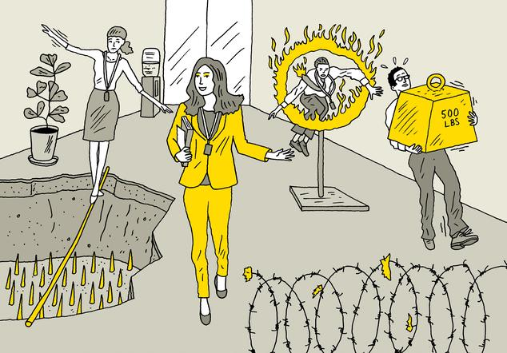
By Robert I. Sutton
Aug. 12, 2018 10:09 p.m. ET

Leaders don’t mean to waste their employees’ time. Unfortunately, many of them heap unnecessary work on the people below them in the pecking order—and are downright clueless that they’re doing it. They give orders without realizing how much work those directives entail. They make offhand comments and don’t consider that their employees may interpret them as commands. And they solicit opinions without realizing that people will bend over backward to tell them what they want to hear—rather than the whole truth, warts and all. That is what my Stanford colleague Huggy Rao and I have learned from our “organizational friction” project. We’re studying why some organizations make the right things too difficult to do and the wrong things too easy to do—and what leaders can do to avoid such missteps.

The roots of waste
Before describing how to avoid it, it’s important to understand why so many leaders are blind to the ways they waste employees’ time. First, many bosses don’t pay enough attention to followers’ behaviors, needs and troubles.
The CEO of one firm I studied, for instance, fell in love with new management concepts, such as “lean” operations, and frequently announced new companywide initiatives—often once a quarter. But those announcements typically didn’t take into account initiatives from previous quarters. Employees were often asked to drop what they were doing before and start a new mission from scratch. Each new initiative entailed a new round of training, meetings and paperwork. Even though many employees learned the fine art of “fad surfing”—that is, complying with the changing directives as little as possible and focusing on their core work—they still wasted a lot of time. At many companies, meanwhile, employees become aware of how self-absorbed their bosses are, and so focus on telling the bosses what they think the bosses want to hear, and on doing things they believe will keep their bosses happy. This leads to what Dr. Rao and I call “executive magnification,” when people bent on buttering up a leader react far more strongly to his or her words or actions than the leader ever intended.

MORE IN LEADERSHIP
For example, an executive told me a story, perhaps apocryphal, about a CEO who commented that there were no blueberry muffins at a breakfast meeting. He wasn’t especially fond of them; it was just small talk. After that, his staff sent strict instructions about this preference to every host. It took him years to discover why there were piles of blueberry muffins every place he went. In another case, an executive asked his workers why there was a new door in one room. His people took it as a criticism, so they plastered and painted it over to please him. When he explained that he had not meant it as complaint, they put the door back in.

Not all smiles
Executive magnification can generate far more troubling waste. In the 1980s, a co-researcher and I studied a retail chain that spent millions on improving employee courtesy. They used training, incentives and contests to encourage clerks to offer smiles, eye contact, greetings and thanks to customers. This campaign was launched, in part, because the CEO complained about a rude clerk he encountered. It took a couple of years before he realized his brief rant had triggered a big campaign that he never wanted—and he ordered the company to wind it down. Another way that executives waste employees’ time, slow the work and add to their own burdens is by “cookie licking,” a term inspired by sneaky children who lick cookies to deter others from eating them. Cookie licking happens when leaders of growing companies don’t realize or accept that the time has come to delegate responsibilities. For instance, it made sense for one CEO we know to interview every job candidate when her company had 25 employees—but not when it grew to over 500. Yet she insisted on doing so even though scheduling interviews placed enormous burdens on her assistant and human-resources staffers, as her schedule became more packed. The company also lost several top prospects, who accepted jobs elsewhere before interviews with the CEO could be scheduled. A year too late, the CEO decided she was too busy to interview every candidate. But she remained oblivious to how her actions had burdened colleagues and driven away candidates.

Listening to criticism
How can leaders stop making these mistakes? How can they recognize that they have created an atmosphere where wasting time is more the norm than the aberration? They can start by being skeptical when they hear nothing but sunny feedback from followers. They should also be vigilant about their minor complaints and offhand remarks. When they say anything that could be misconstrued as a command or desire for change, it helps to add, “Please don’t do anything, I am just thinking out loud.” And when leaders encourage candor and criticism from employees, they should make sure it isn’t just lip service, and back it up with actions. A film director we interviewed described how he was dissecting the flaws in a scene for his team. Then one member sighed. The director called him on it, and the man mumbled that he didn’t have anything to add. But when the director nudged him to speak, he made a suggestion about changing the scene that the director praised and implemented.

A radical change
As part of embracing complaints, leaders might consider a radical (and often uncomfortable) change in how they define star employees. Research on psychological safety led by Amy Edmondson at the Harvard Business School shows that the best employees for promoting organizational learning are often those who never leave well enough alone, pointing out mistakes and flawed practices. But those who management rates as top performers are often those who silently do what they’re told and what has always been done—and don’t annoy their superiors with complaints and questions about flawed practices.

Newsletter Sign-up
My work with Dr. Rao reveals similar problems: Employees who start big programs are often celebrated, but rarely those who end old, obsolete and ineffective programs and practices. And managers who lord over big teams and keep adding underlings are rewarded with prestigious titles and big raises—even when their ever-expanding army of bureaucrats adds unnecessary rules and procedures that sap time and energy from people who do the most important work.
Instead, the best leaders discourage this addition sickness by praising, promoting and paying employees who remove destructive friction and waste. As with most positive steps, playing the subtraction game is much like mowing a lawn. Leaders can’t just do it once and declare victory. They have to do it on a regular basis, or else the old bad habits will creep back into place.

Dr. Sutton is a professor in the department of management science and engineering at Stanford University and co-author of “Scaling Up Excellence.” He can be reached at reports@wsj.com.

